FA8 Espiritu

Joseph Raphael M. Espiritu

2024-04-11

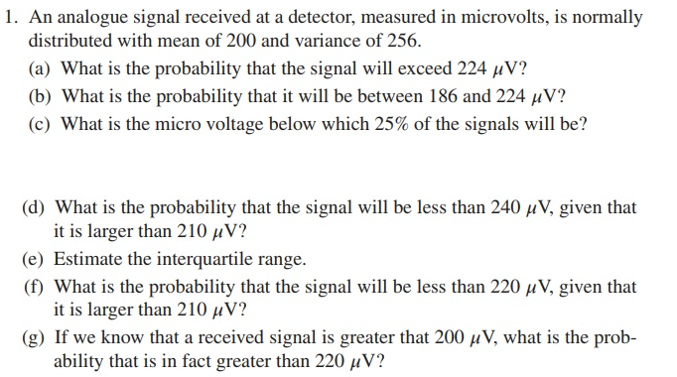

FA8 Question 1

Letter A Answer:

print(prob224)

## [1] 0.0668072

cat("It has a " , round(prob224*100,2), "% probability that the signal will exceed 224 microvolts")

## It has a 6.68 % probability that the signal will exceed 224 microvolts

Letter B Answer:

print(pnorm(224, mean1, sqrt(var1)))

## [1] 0.9331928

print(pnorm(186, mean1, sqrt(var1)))

## [1] 0.190787

print(prob224to186)

## [1] 0.7424058

cat("It has a " , round(prob224to186*100,2), "% probability that the signal will be between 186 to 224 microvolts")

## It has a 74.24 % probability that the signal will be between 186 to 224 microvolts

Letter C Answer:

print(percentile25)

## [1] 189.2082

cat("The micro voltage below 25% percentile is", percentile25)

## The micro voltage below 25% percentile is 189.2082

Letter D Answer:

print(pnorm(240, mean1, sqrt(var1)))

## [1] 0.9937903

print(pnorm(210, mean1, sqrt(var1)))

## [1] 0.7340145

print(prob240to210)

## [1] 0.2597759

cat("It has a " , round(prob240to210*100,2), "% probability that the signal will be less than 240 but greater than 210 microvolts")

## It has a 25.98 % probability that the signal will be less than 240 but greater than 210 microvolts

Letter E Answer:

print(interquartile)

## [1] 189.2082 210.7918

cat("The interquartile Range is:", interquartile[2]-interquartile[1])

## The interquartile Range is: 21.58367

Letter F Answer:

print(pnorm(220, mean1, sqrt(var1)))

## [1] 0.8943502

print(pnorm(210, mean1, sqrt(var1)))

## [1] 0.7340145

print(prob220to210)

## [1] 0.1603358

cat("It has a " , round(prob220to210*100,2), "% probability that the signal will be less than 220 but greater than 210 microvolts")

## It has a 16.03 % probability that the signal will be less than 220 but greater than 210 microvolts

Letter G Answer:

print(1 - pnorm(200, mean1, sqrt(var1)))

## [1] 0.5

print(1 - pnorm(220, mean1, sqrt(var1)))

## [1] 0.1056498

print(probgreater200then220)

## [1] 0.3943502

cat("It has a " , round(probgreater200then220*100,2), "% probability that the signal will be greater than 200 microvolts but also be greater than 220 microvolts already")

## It has a 39.44 % probability that the signal will be greater than 200 microvolts but also be greater than 220 microvolts already

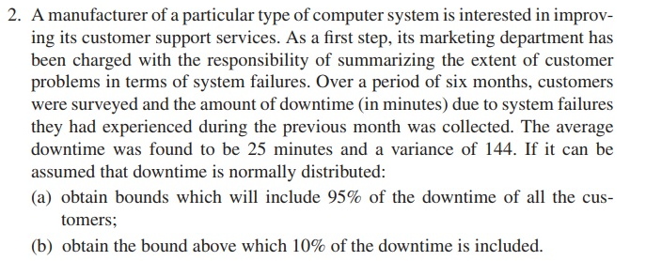 Letter G Answer:

# Given parameters  
mean_downtime <- 25  
variance_downtime <- 144  
  
# (a) Obtain bounds which will include 95% of the downtime of all the customers  
lower_bound_95 <- qnorm(0.025, mean_downtime, sqrt(variance_downtime))  
upper_bound_95 <- qnorm(0.975, mean_downtime, sqrt(variance_downtime))  
  
# (b) Obtain the bound above which 10% of the downtime is included  
bound_above_10 <- qnorm(0.90, mean_downtime, sqrt(variance_downtime))  
  
# Output the results  
print(paste("Bounds including 95% of downtime:", round(lower_bound_95, 2), "to", round(upper_bound_95, 2)))

## [1] "Bounds including 95% of downtime: 1.48 to 48.52"

print(paste("Bound above which 10% of downtime is included:", round(bound_above_10, 2)))

## [1] "Bound above which 10% of downtime is included: 40.38"